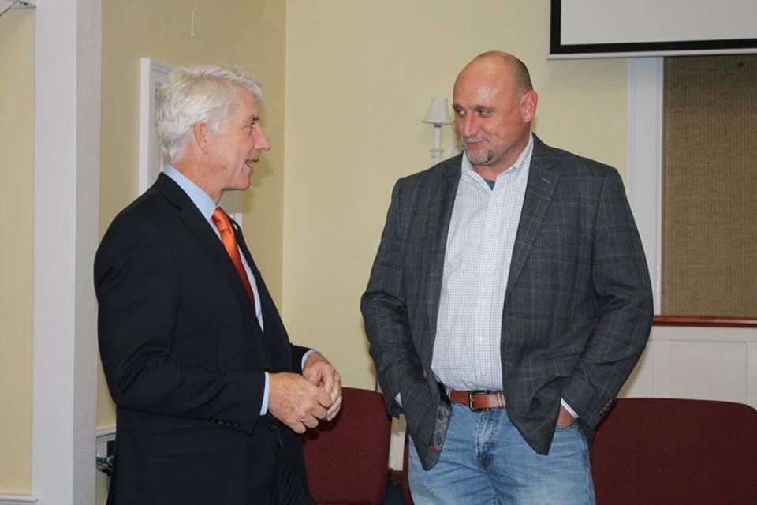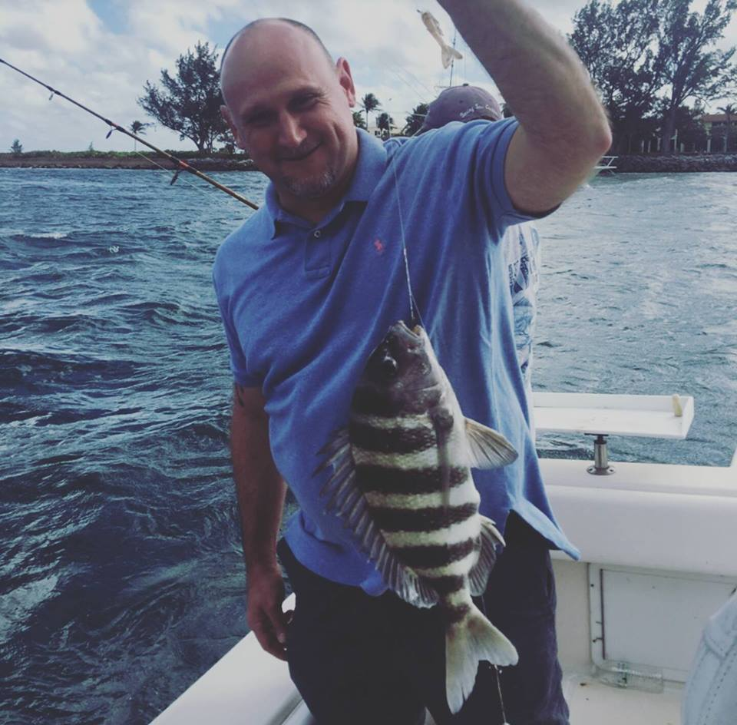David Rook

**Operations Manager – McShin Foundation**

David, a father of two, has been an electrician for several years spending the majority of that time in Virginia and Florida battling a substance use disorder. He tried several times over the years to find recovery, going to treatment centers, sober living houses, etc. His clean date is March 6th, 2012 and he has been working as Senior Peer Leader and Intake Specialist since August 2012. In 2015 David was promoted to Operations Manager. In 2012 he was elected Chairman of the board for the Virginia Association of Recovery Residences, (VARR). In 2013 he was selected as McShin Employee of the year, and was awarded Richmond City Jail Beloved Volunteer Award for his time spent delivering recovery support services to the incarcerated.  He was invited to the White House by the ONDCP, and has co-hosted several fundraisers for future politicians who support recovery.

