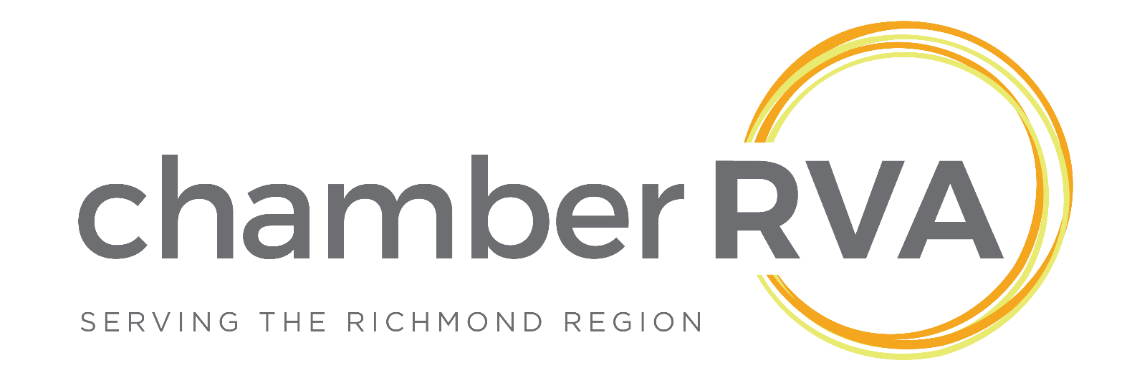ChamberRVA Small Business Development Center  
Fall 2016 Startup Development Internship

October 3rd – December 16 th

**About Internship:**ChamberRVA is seeking a student intern to join its Startup Development team known as “The Thrive Network” for the Fall 2016 semester. The Thrive Network intern is on the front line of RVA’s entrepreneurial ecosystem. The position requires both technological expertise, as well as good interpersonal communication skills. The position will provide 1st level counseling ascertaining clients’ needs and either supply the information they seek or refer them to the appropriate resource in RVA’s entrepreneurial ecosystem. The position will be responsible for interfacing directly with the interactive database named Thrive to extract information to be reported through Small Business Development Center (SBDC) channels. The position will be responsible for the timely completion of all recordkeeping required by the SBDC, and will enhance the overall effectiveness of the organization by providing information and administrative support. The Thrive Network intern will work with part-time mentors to develop educational offerings through the Thrive Network.

This internship reports to the Senior Vice President, Strategy & Brand. It offers the intern a unique chance to not only connect with the frontline of RVA’s entrepreneurial ecosystem but also to help make a significant positive impact in the Greater Richmond Region by helping startups grow their businesses and be successful.

**Required Skills:**  
Highly motivated, creative, with a desire to work directly with entrepreneurs to help them grow their businesses

Strong project management and organizational skills

Strong communicator with impeccable interpersonal skills; outstanding written and verbal communication skills

Able to take initiative and work independently in a fast-paced environment

Enjoys learning and continually seeking new ways to grow personally and professionally

Motivated, passionate, driven to succeed, and has a "can-do" attitude

Ability to work with a diverse group of people

In-depth knowledge and understanding of social media platforms and how they can be deployed in different scenarios is a plus

**Schedule & Hours:**This internship will begin on Monday, October 3rd and run for 10 weeks (through December 16th). Each week the intern will be expected to be available and onsite for 8-10 hours a week, between normal business hours (9am – 5pm). The schedule can be flexible depending on class schedule, and does not need to be continuous blocks of time.

**Location**The location of this internship will be at the Chamber’s offices located at 919 East Main Street, Ste. 1700, in downtown Richmond. Intern must be able to provide their own transportation.

**Compensation**$10 / hour

**Interested in applying?**   
Please send a cover letter and resume to Chrystal Neal at [chrystal.neal@chamberrva.com](mailto:chrystal.neal@chamberrva.com)Applications will only be considered from current students (undergraduate or post graduate).

**About The Chamber**ChamberRVA is a not-for-profit business membership association. We are building a thriving business community by supporting the success of our members, providing a strong business voice and developing leaders and entrepreneurs. We aim to be the driver of a business community that is a transformational force in a region recognized as a magnet for talent, a hotbed for innovation and an exciting place to grow a business. Since 1867, ChamberRVA has taken the lead to enhance and institute change in the Richmond Region, making the region an ideal location for businesses to prosper.