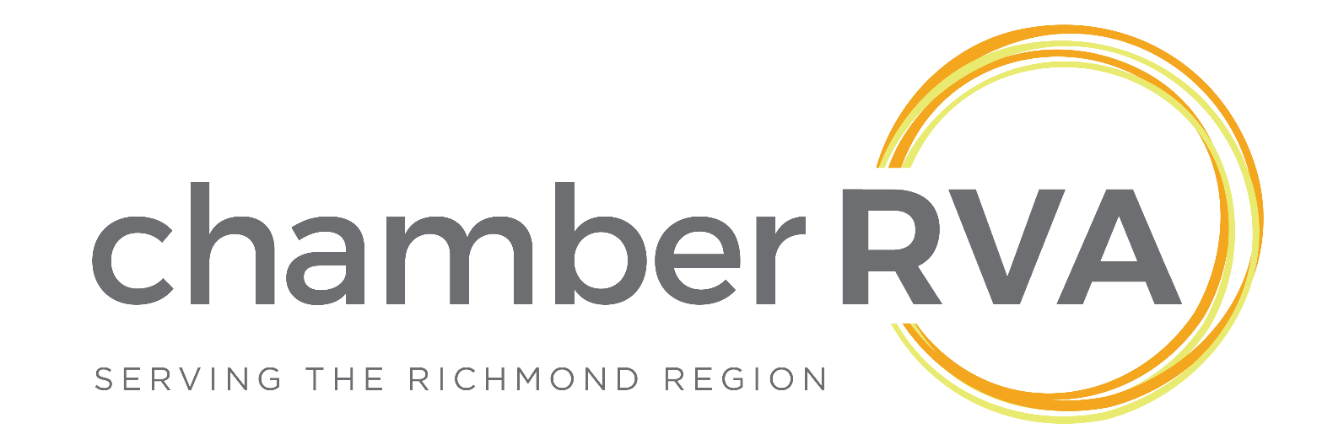ChamberRVA Marketing & Communications  
Fall 2016 Digital Marketing Internship

October 3rd – December 16 th

**About Internship:**ChamberRVA is seeking a creative student intern to join its Digital team for the Fall 2016 semester. The primary function of this position will be to assist with the creation and management of digital newsletters. The ideal candidate will have a strong writing/copyediting background, experience using e-newsletter publishing tools such as Constant Contact or MailChimp, coding basic HTML and CSS and digital graphic design experience.

This internship reports to Senior Vice President, Strategy & Brand. It offers the intern a unique chance to not only hone their communication and technical skills, but also to help make a significant positive impact in the Richmond Region by helping promote the efforts of the Chamber’s members as well marketing Chamber programming that supports those businesses.

**Required Skills:**  
Strong writer with copyediting experience  
Basic HTML and CSS coding abilities  
Proficiency in Adobe Photoshop, Illustrator and/or InDesign  
Strong attention to detail  
Quick learner and eagerness to learn new skills  
Must be able to make own travel arrangements to be onsite

**Bonus Skills:**  
Experience designing newsletters in Constant Contact

**Schedule & Hours:**This internship will begin on Monday, October 3rd and run for 10 weeks (through December 16th). Each week the intern will be expected to be available and onsite for 8-10 hours a week, between normal business hours (9am – 5pm). The schedule can be flexible depending on class schedule, and does not need to be in continuous blocks of time.

**Location**The location of this internship will be at the Chamber’s offices located at 919 East Main Street, Ste. 1700, in downtown Richmond. Intern must be able to provide their own transportation.

**Compensation**$10 / hour

**Interested in applying?**   
Please send a cover letter and resume to Chrystal Neal at [chrystal.neal@chamberrva.com](mailto:chrystal.neal@chamberrva.com)Applications will only be considered from current students (undergraduate or post graduate).

**About The Chamber**ChamberRVA is a not-for-profit business membership association. We are building a thriving business community by supporting the success of our members, providing a strong business voice and developing leaders and entrepreneurs. We aim to be the driver of a business community that is a transformational force in a region recognized as a magnet for talent, a hotbed for innovation and an exciting place to grow a business. Since 1867, ChamberRVA has taken the lead to enhance and institute change in the Richmond Region, making the region an ideal location for businesses to prosper.