STUDENT CAREER INTERESTS WORKSHEET
- Look at this list of skills that employers are looking for:

WHAT YOUR FUTURE EMPLOYER WANTS FROM YOU
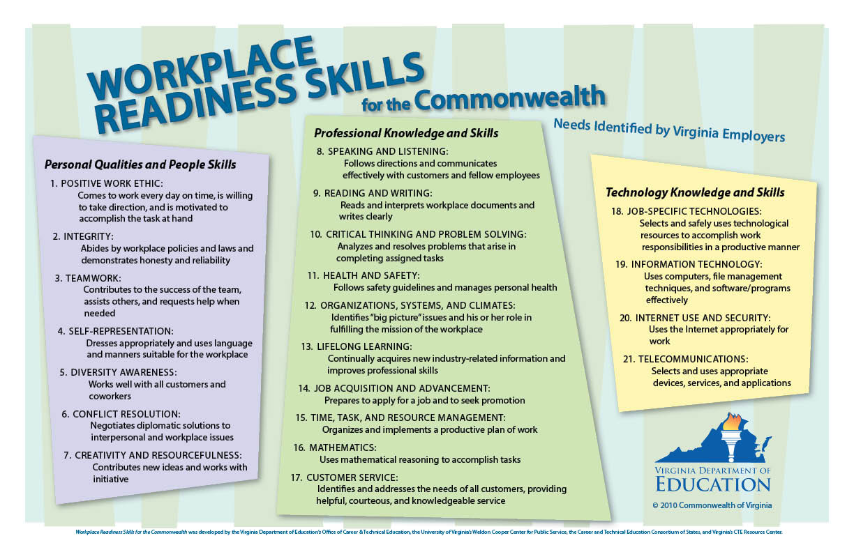
Which two of the skills are you best at?
______________________________ ______________________________

Which two skills do you most need to improve?
______________________________ ______________________________

- My three best personal qualities or characteristics are:
_______________________ _______________________ _______________________

- My top three interests (likes, hobbies, and fun activities) are:
_______________________ _______________________ _______________________

- My favorite school subjects are:
__________________________________________________________________________

- What career are you currently most interested in pursuing?
__________________________________________________________________________

